CIT438/538
Lab#1: AWS EC2

You will use the CLI to manage the Amazon EC2 service. You will use the CLI commands to launch instances, manipulate security groups, and more.

Tools and Materials
- One Ubuntu VM
- AWS credentials
- AWS CLI

Note: You need to replace words in bold with your information.
Questions will be in red. Show your output for commands.
Part 1: Creating a security group and a key pair
    - Start your Ubuntu VM

2. Create a security group and use your UC username to name your security group via the following command:
aws ec2 create-security-group --group-name usersam2 --description "my security group" --vpc-id vpc-05c778e2d85733c8b
What’s the output?

{
"GroupId": "sg-0e8b8b55ca4766f03",
"SecurityGroupArn": "arn:aws:ec2:us-east-1:078646182234:security-group/sg-0e8b8b55ca4766f03"
}

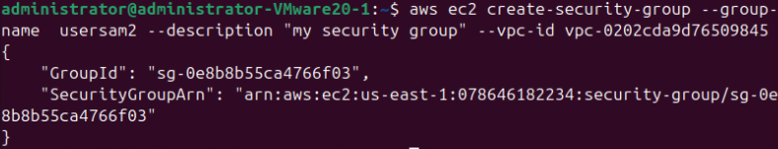
3. Add rules to the security group. Define two rules that allow incoming traffic over port 22 and port 80 for SSH and HTTP and add them to your security group via the following commands:

aws ec2 authorize-security-group-ingress --group-id YOUR_SEC_GROUP_ID --protocol tcp --port 22 --cidr 0.0.0.0/0

aws ec2 authorize-security-group-ingress --group-id YOUR_SEC_GROUP_ID --protocol tcp –port 80 --cidr 0.0.0.0/0
You can verify if the rules are added properly to your security group via the following command:

aws ec2 describe-security-groups --group-id YOUR_USERNAME
What’s the output?
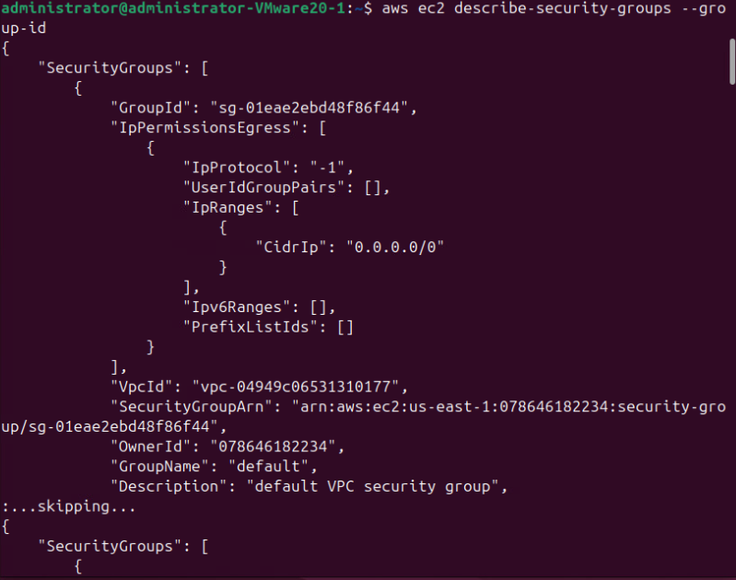
4. A key pair will be used when connecting to an EC2 instance. You can use the following command to create and save the key pair:

aws ec2 create-key-pair --key-name your_username-key --query 'KeyMaterial' --output text > your_username-key.pem

Did you see your_username-key.pem under your current directory? Is your_username-key.pem your private key or your public key?
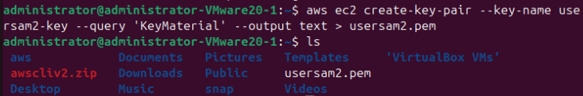
You need to modify permissions to the your_username-key.pem file so that only you can access it.
chmod 400 your_username-key.pem
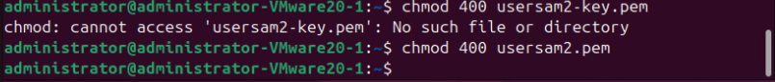
Part 2: Instantiating an image
5. To start an instance, you can run the following command:
aws ec2 run-instances --image-id ami-013f17f36f8b1fefb --count 1 --instance-type t1.micro --key-name YOUR_KEY --security-group-ids YOUR_SEC_GROUP --subnet-id YOUR_SUBNETID --associate-public-ip-address

aws ec2 run-instances --image-id ami-08982f1c5bf93d976 --count 1 --instance-type t3.micro --key-name sid1 --security-group-ids sg-04e07ebe0dc0d3b7c --subnet-id subnet-0395bca748f595a5e --associate-public-ip-address

aws ec2 run-instances --image-id ami-08982f1c5bf93d976 --count 1 --instance-type t3.micro --key-name sid1 --security-group-ids sg-04e07ebe0dc0d3b7c --subnet-id subnet-0395bca748f595a5e --associate-public-ip-address
What’s the output? What’s your instance ID?
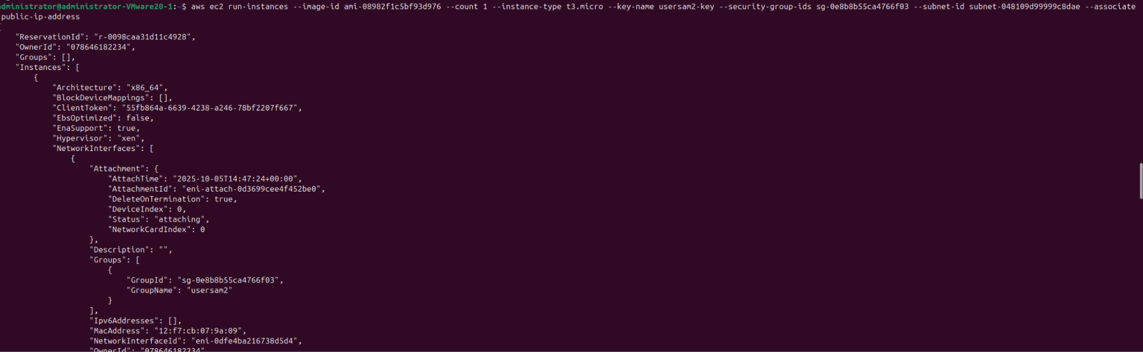
Instance ID: i-0547952e311617a17

6. You need the instance’s public IP address or public DNS name to access the instance. After waiting for 30 seconds, you can use the following command to find out the network information:
aws ec2 describe-instances --instance-ids YOUR_INSTANCE_ID
aws ec2 describe-instances --instance-ids i-0547952e311617a17

What’s the output? What is the public IP address of your instance?
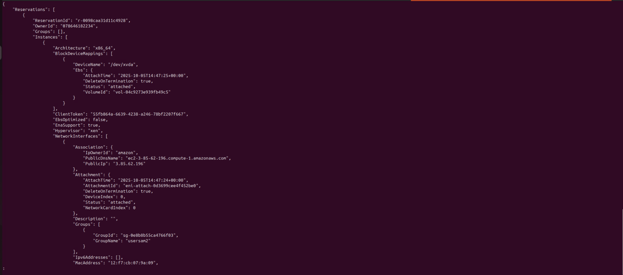
3.85.62.196
Part 3: logging in to your instance
7. You can use the following ssh command to connect to the instance:
ssh -i your_username-key.pem ubuntu@the_public_IP_address_of_your_instance
ssh -i usersam2.pem ubuntu@3.85.62.196
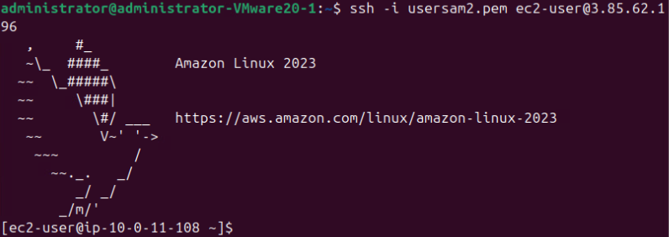
If you see “Are you sure you want to continue connecting (yes/no)?”, please type “yes” to continue. When you see the prompt, type “sudo –s” to switch to the root.

8. Please run “cat /proc/meminfo” and “cat /proc/cpuinfo” on a terminal of your instance. What is the CPU frequency of your instance? What is the memory size of your instance? Please run “uname -a”. Is your instance a 32-bit platform or a 64-bit platform?
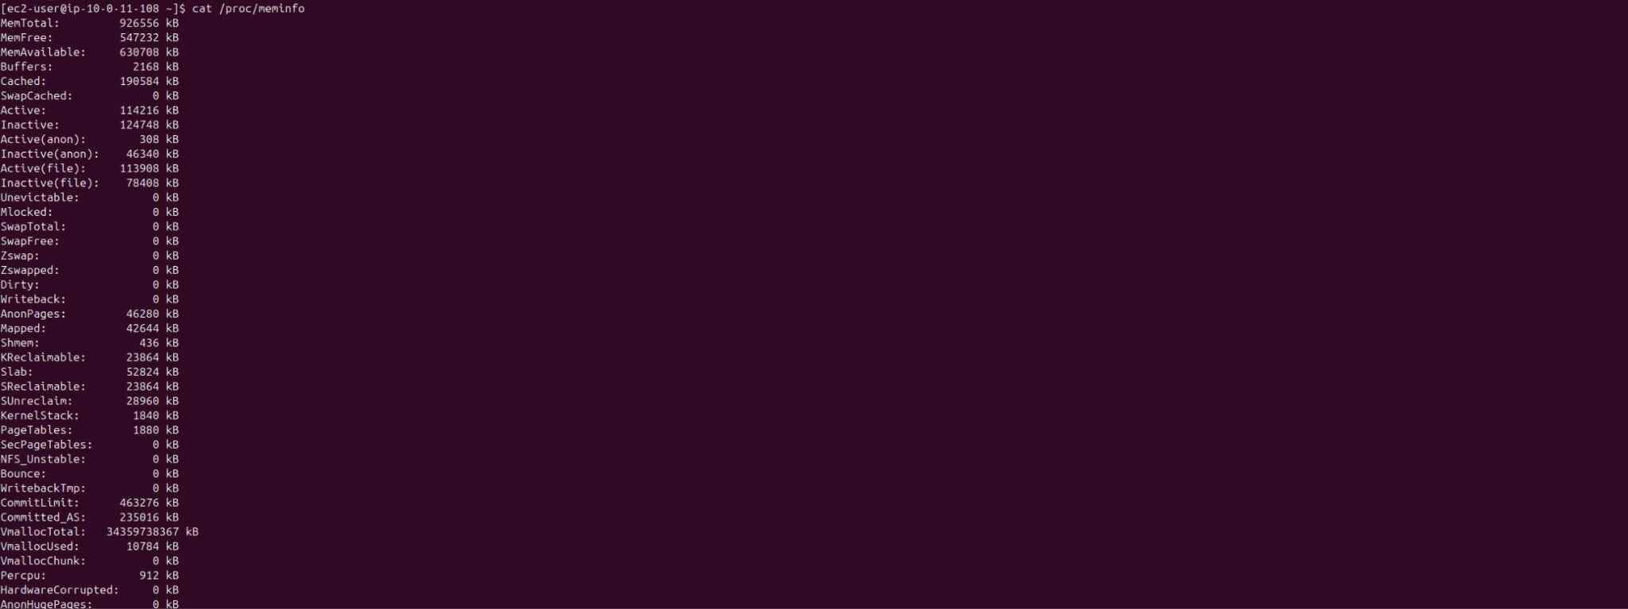

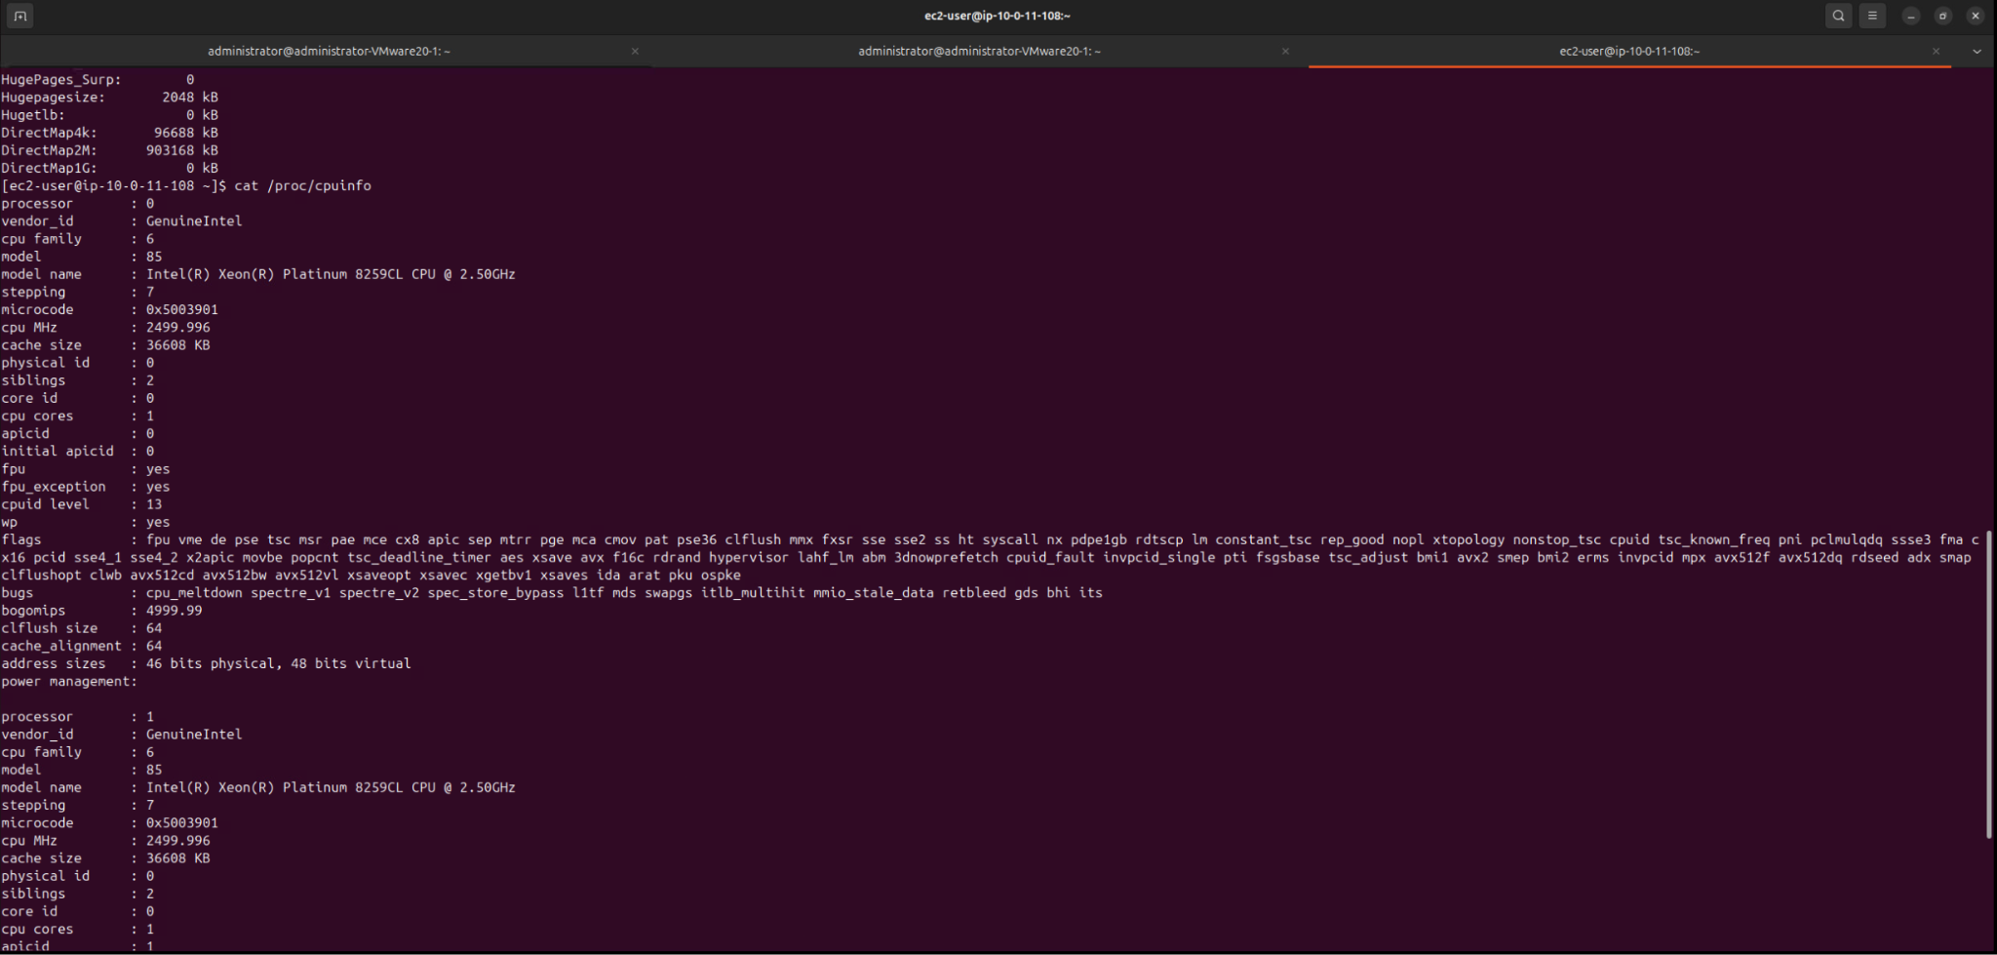
CPU: 2499.996
Memory: 926556 kB
Platform: 64 bit

9. Please run the following commands to install and start an apache web server on your EC2 instance:

apt-get update
apt-get install -y apache2
apachectl restart

Then you can enter the following command to see if your server is up and running properly:
systemctl status apache2

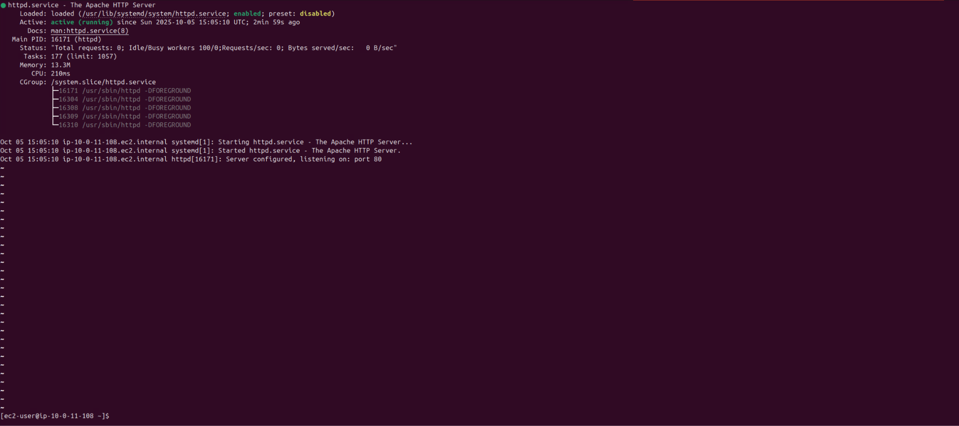
10. Start a browser and type “http://the_public_IP_address_of_your_instance/” to access to the Apache web server in your instance. What did you see in your browser? Please give me a screen capture of your browser.
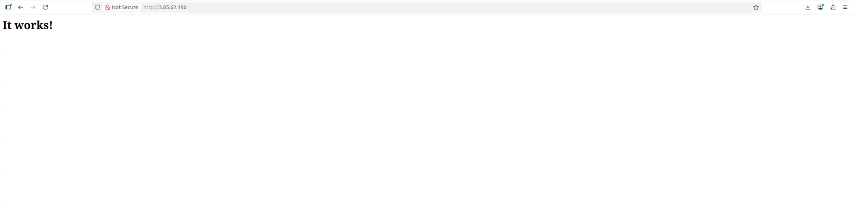
It works!

Part 4: Terminating an instance
You will be billed as long the instance is running, so you will need to shut it down when you're done.
11. Start another terminal in your VM and run the following command to terminate your instance:
aws ec2 terminate-instances --instance-ids your_instance_id
What is the output?
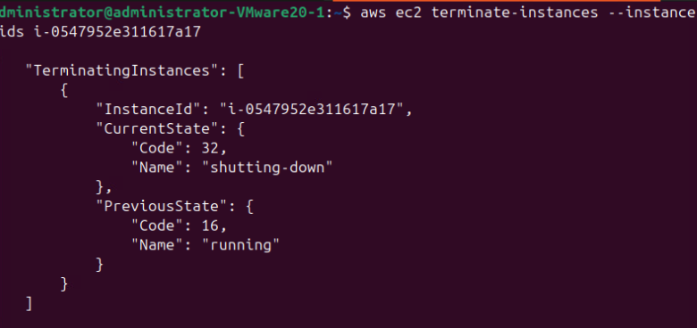
TerminatingInstances": [
{
"InstanceId": "i-0547952e311617a17",
"CurrentState": {
"Code": 32,
"Name": "shutting-down"
},
"PreviousState": {
"Code": 16,
"Name": "running"
}
}
]
}

Part 5: Instantiating an image with customized data
12. We manually installed the Apache web server in step 10. Let’s create a shell script called apache.sh under your current directory. The content of apache-install is as follows:
#!/bin/bash
# Prevent apt-get from bringing up any interactive queries
export DEBIAN_FRONTEND=noninteractive
# Upgrade packages
sudo apt-get update
# Install Apache
sudo apt-get install -y apache2

You can use the --user-data option of the run-instances command to automatically run a shell script during the instance launch time. The following is the run-instances command:

aws ec2 run-instances --image-id ami-013f17f36f8b1fefb --count 1 --instance-type t1.micro --key-name your_key_name --security-group-ids your_security_grp_name --subnet-id your_subnet_id --associate-public-ip-address --user-data file://path_to_your_apache.sh

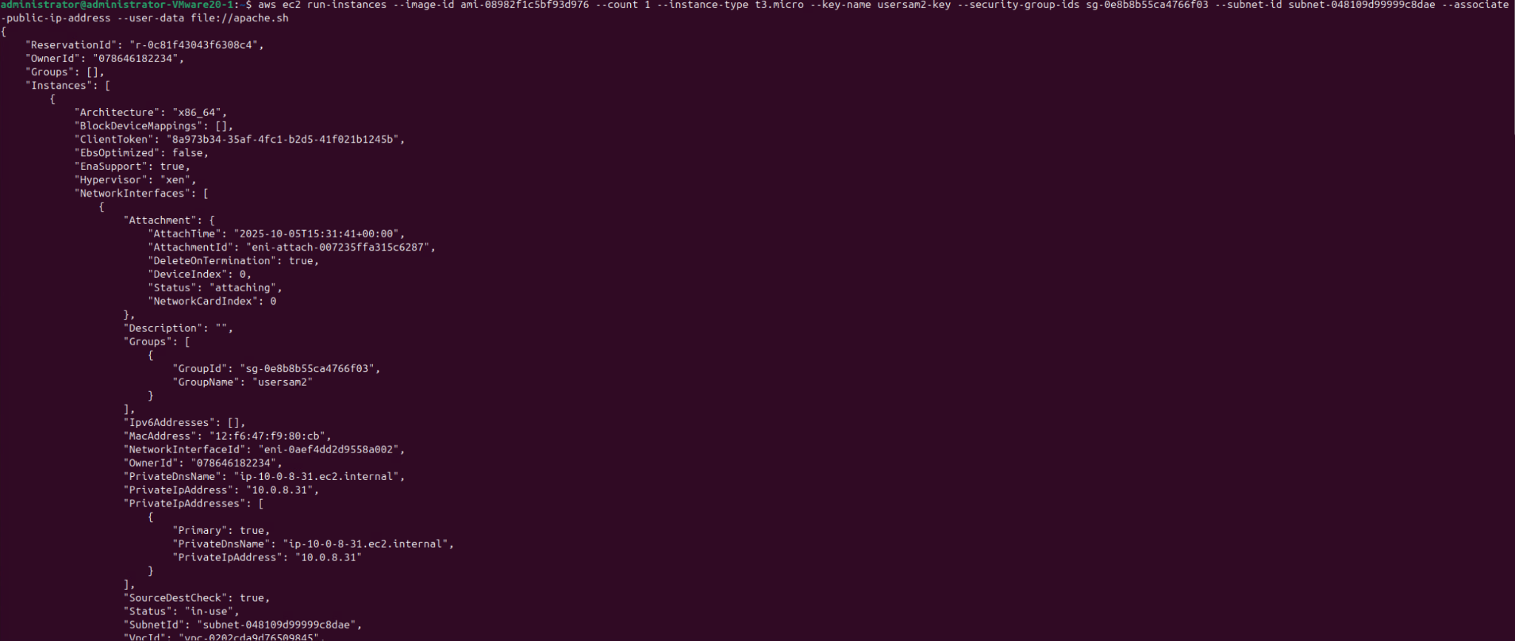
aws ec2 run-instances --image-id ami-013f17f36f8b1fefb --count 1 --instance-type t1.micro --key-name examplekeyit3037 --security-group-ids sg-05c453212f0742465 --subnet-id subnet-04240690d747ff980 --associate-public-ip-address --user-data file://apache.sh

13. Log onto the instance and switch to the root. Then run the following command to verify if the Apache server is installed and running.

systemctl status apache2

If this is not running use this command to start apache and then check again with the above command

sudo systemctl start apache2

What is the output?
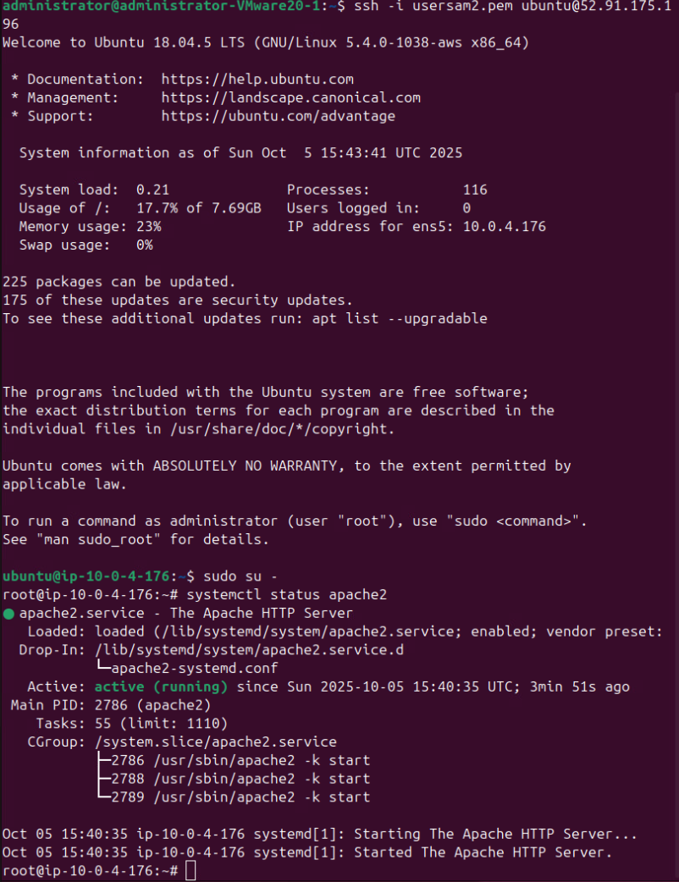

Go to your browser and enter the ec2 instance public IP. What do you see?
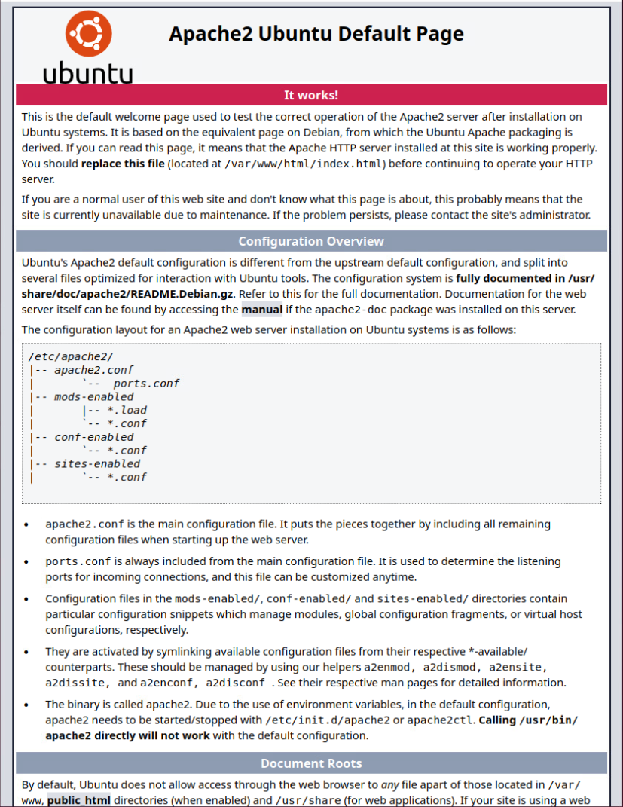
14. Please terminate the instance. What command did you use to terminate the instance?
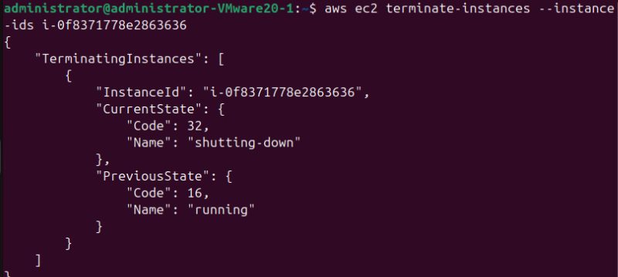

aws ec2 describe-instances --instance-ids i-0f8371778e2863636

Part 1 Docker and Premade Containers
- First you will need to launch and EC2 instance for us to host our Docker container. We do this with the following command:
aws ec2 run-instances --image-id ami-013f17f36f8b1fefb --count 1 --instance-type t1.micro --key-name YOUR_KEY --security-group-ids YOUR_SEC_GROUP --subnet-id YOUR_SUBNETID --associate-public-ip-address
- Describe the instance to get ip. What command did you use?
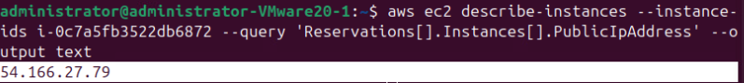
aws ec2 describe-instances --instance-ids i-0c7a5fb3522db6872 --query 'Reservations[].Instances[].PublicIpAddress' --output text

- Next you will need to connect to your EC2 instance we do this with the following command:

ssh -i your_username-key.pem ubuntu@the_public_IP_address_of_your_instance

- Next you need to switch to root, we do this with the following command
sudo -s

- Next we must update our instance with the following command:
apt update

- Following this, we can download docker using the following curl command to download the download script for Docker setup:

curl -fsSL https://get.docker.com -o get-docker.sh

sudo sh get-docker.sh

- After running the script we can verify docker downloaded properly using the following command:
docker --version

What is the output?
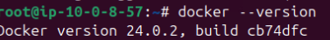
Docker version 24.0.2, build cb74dfc

- Docker maintains a repository of popular docker containers that are free to use in docker hub, a repository that you can upload and maintain versions of your container. If you wish to run one of these, you simply specify it with the docker run command which pulls the image of the container if you do not have it and runs it. Enter the following command to run the basic hello-world script:

docker run hello-world

What is the output?
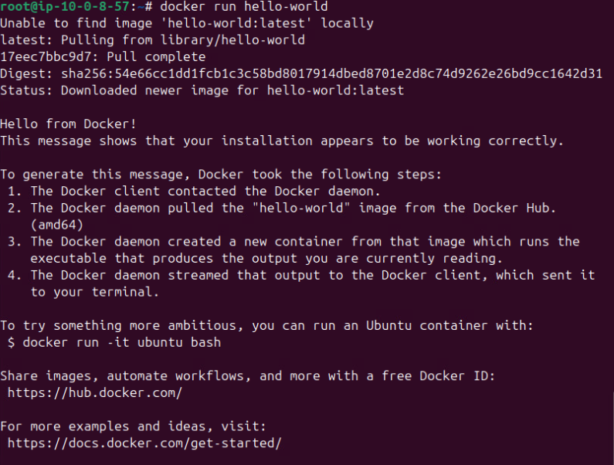
root@ip-10-0-8-57:~# docker run hello-world
Unable to find image 'hello-world:latest' locally
latest: Pulling from library/hello-world
17eec7bbc9d7: Pull complete
Digest: sha256:54e66cc1dd1fcb1c3c58bd8017914dbed8701e2d8c74d9262e26bd9cc1642d31
Status: Downloaded newer image for hello-world:latest

Hello from Docker!
This message shows that your installation appears to be working correctly.

To generate this message, Docker took the following steps:
1. The Docker client contacted the Docker daemon.
2. The Docker daemon pulled the "hello-world" image from the Docker Hub.
(amd64)
3. The Docker daemon created a new container from that image which runs the
executable that produces the output you are currently reading.
4. The Docker daemon streamed that output to the Docker client, which sent it
to your terminal.

To try something more ambitious, you can run an Ubuntu container with:
$ docker run -it ubuntu bash

Share images, automate workflows, and more with a free Docker ID:
https://hub.docker.com/

For more examples and ideas, visit:
https://docs.docker.com/get-started/

- Following this we can look at a more interactive model. Cowsay is a container on docker that provides an image of a cow saying the text following the run command. Similarly, whalesay provides the same thing, but this time it is the logo of docker, a whale, that says the text. Enter the following command along with the proceeding text:

docker run docker/whalesay cowsay This example shows you a more in depth docker example!

What is the output?
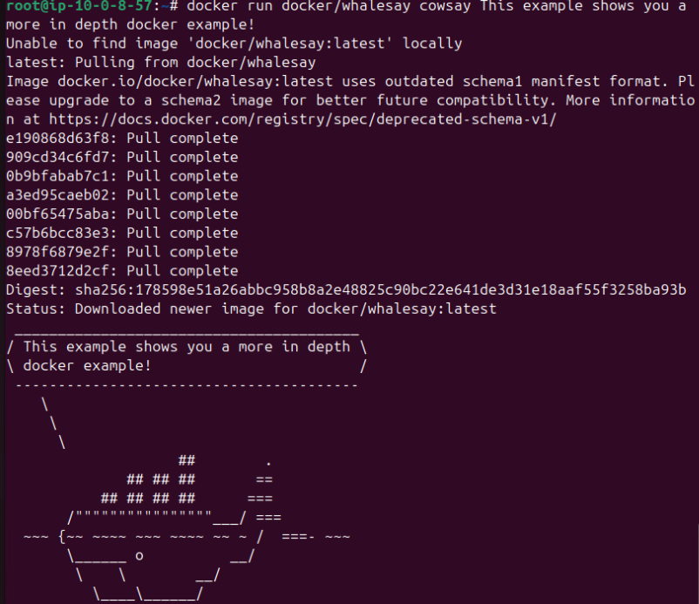

- Exit your EC2 instance and delete it. What command did you use?
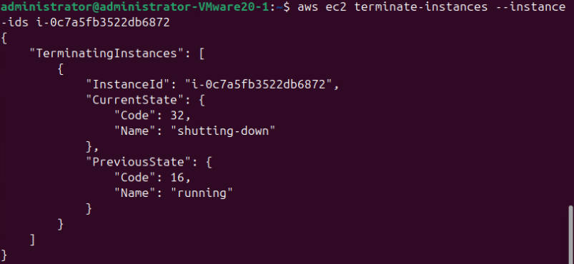
aws ec2 terminate-instances --instance-ids i-0c7a5fb3522db6872
Part 2 Making your own Dockerfile and launching it in EC2

- In the next example you will create your own docker file. To start we must launch our instance to build our docker deployment:
- After docker is installed, we can now create our Dockerfile. We do so with the following command:

touch Dockerfile

*IMPORTANT*
*Be sure to capitalize the “D” in Dockerfile, as docker is case sensitive.*

Then edit the file with the following content:

FROM ubuntu:18.04

# Install dependencies
RUN apt-get update && \
apt-get -y install apache2

# Install apache and write hello world message
RUN echo 'Hello World, this is to test our apache container!' > /var/www/html/index.html

# Configure apache
RUN echo '. /etc/apache2/envvars' > /root/run_apache.sh && \
echo 'mkdir -p /var/run/apache2' >> /root/run_apache.sh && \
echo 'mkdir -p /var/lock/apache2' >> /root/run_apache.sh && \
echo '/usr/sbin/apache2 -D FOREGROUND' >> /root/run_apache.sh && \
chmod 755 /root/run_apache.sh

EXPOSE 80

CMD /root/run_apache.sh

This tells docker that we want it to start in ubuntu and install apache. Following that we will echo our test text to our index page to see that our container is working. After this, we instruct docker to configure the dependency files and apache. Finally, the last two sections expose port 80 so we can connect to our container through http, and the cmd command instructs our container to run the apache script.

- Once we have our docker file, we can build our docker image, we do that with the following command:

docker build -t hello-apache .

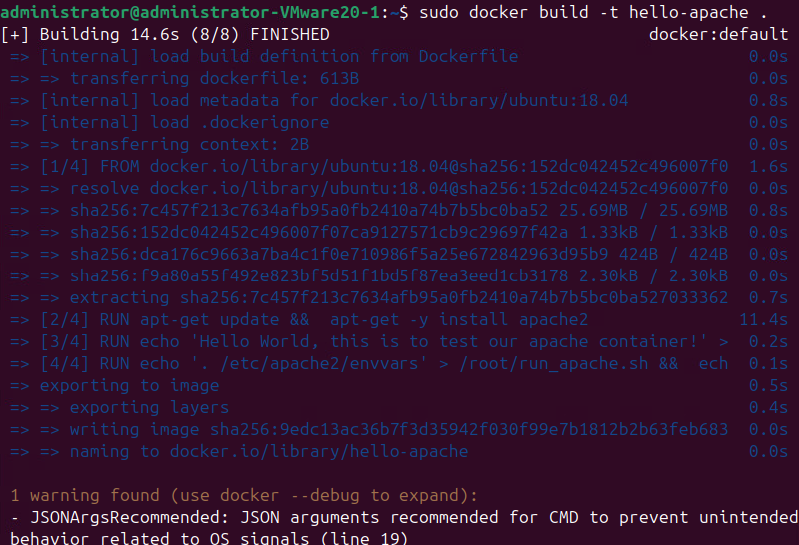
- To list the docker images we have we can use the following command:

docker images
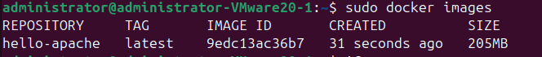
If we wanted a specific image(s), we can use the –filter operator to search by name like so:

docker images --filter reference=hello-apache

What’s the output to both of these commands?
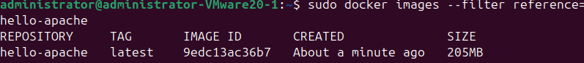
REPOSITORY TAG IMAGE ID CREATED SIZE
hello-apache latest 9edc13ac36b7 About a minute ago 205MB
- In order to run our image, we have to specify a few run conditions with our created container.
The -t option is used to tag a name to our container.
The -I option keeps our docker container running.
The -p with 80:80 tells docker to run our container on port 80 so we can connect to our container through the browser.

docker run -t -i -p 80:80 hello-apache

*Disregard the error that says it cannot find the fully qualified domain name your container should still function normally*
Go to your browser and enter the ec2 instance public IP. What do you see?

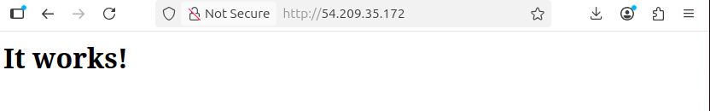
It works!
- Exit your EC2 instance and delete it. What command did you use?
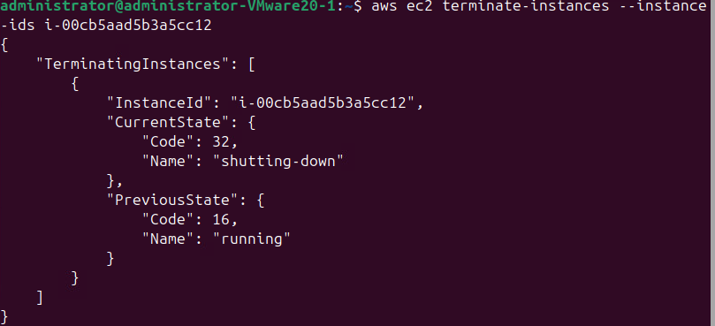
aws ec2 terminate-instances --instance-ids i-00cb5aad5b3a5cc12

Submission instruction

After completing this work, submit this word document with your answers to the Canvas. In your word document, your answers should be in blue print.

